THE EFFECTINESS OF REDUCING GREENHOUSE GAS EMISSION OF BIOGAS DIGESTERS AT VAN CU VILLAGE, THUA THIEN HUE PROVINCE
Tran Thi Tu*, Nguyen Dang Hai, Tran Quang Loc
Institute of Resources and Environment- Hue University
* Corresponding author’s email address: tttu@hueuni.edu.vn
This paper used some calculation techniques of Intergovernmental Panel for Climate Change (IPCC) to quantify the economic and environmental benefit from greenhouse gas (GHG) emission mitigation at Van Cu rice noodle craft village, Thua Thien Hue province. The greenhouse gas (GHG) emission amount of Van Cu rice noodle craft village was 1,572.3 tonnes of CO₂e/year, in which the GHG emission of households who had activities of pig feeding and rice noodle producing had accounted for 78% of total emissions of the whole village. This study surveyed at 24 households were using biogas works efficiency. Before using biogas works, average GHG emission reached 51.0 tonnes CO₂e/year/household. After using biogas works, total GHG emission of 24 households reduced 267.6 tonnes of CO₂e/year, and every household reduced 11.1 tonnes of CO₂e/year/household. Thus, the total GHG emission amount was cut down 956.7 tonnes of CO₂e/ year, corresponding to revenue from the sale of Certified Emission Reduction units (CERs) was 12.92 million dongs/year.
Keywords: Biogas, Certified Emission Reduction units (CERs), Van Cu village, greenhouse gas (GHG).

1. Introduction
Van Cu rice noodle craft village had 162 households that joined in rice noodle production with 20,330 kg/day in 2016. Wastewater from rice noodle production was 216.5 m³/day. Furthermore, community at this village had recycled by-products to swine breeding with 43.3 kg/day. This village had 264 households joined in swine breeding in the total of 342 households of village. The number of swine was 2,568 heads. The wastewater of swine breeding was about 230.7 m³/day. If wastewater about 403.0 m³/day that is not treat, and discharge into received sources to cause environmental pollution. Furthermore, there were 88% of total households of village that had composted or collected in to tank. And there were 31 households of 264 households (accounted for 11.7%) that had biogas digesters. Thus, solid waste from rice noodle production and swine breeding was also concerned at this village.
2. Material and methods
- Surveying socio- economic information of Van Cu rice noodle craft village, the status of swine breeding, the demand of fuel at village.
- Using some calculation techniques of IPCC (Dong H. et.al, 2006) and United Nations Framework Convention on Climate Change (2009- 2010) to quantify greenhouse gas (GHG) emission at Van Cu rice noodle craft village.
3. Results and Conclusions
3.1 Results
3.1.1 The status at Van Cu rice noodle craft village
According to livestock department, the solid waste from swine breeding was 2.0 kg/head/day (Nguyễn Thanh Sơn et.al, 2008), thus the estimation of solid waste of Van Cu village reached 5.136 kg/day. The average fuel used to 1,952,750 kg/year of wood and 20,578 kg/year gas in 2016. There were 24 households of 31 households that had biogas digesters was used to effectively and had been created gas to serve human life, swine breeding and rice noodle production. In 24 survey households, there were avarge of 5 persons/household, 15 heads/year, 148 kg rice noodle/day. Thus, the total of using fuel at 24 households reached 322,295 kg/year of wood and 1,828.8 kg/year of gas. Therefore, the demand of using fuel from wood accounted for 99% of total fuel demand.
3.1.2 The estimation of GHG emission at Van Cu village
3.1.2.1 The estimation of GHG emission before using biogas digesters
Figure 1 showed the GHG emission due to composting at 24 households. Table 1 showed that total GHG emission of village was 7.593,1 tonnes CO₂e/year. The GHG emission due to burning fuel accounting for high rate with 88.9%, in which 88.7% of CO₂ emission. The GHG emission due to composting only reached 11.1%, in which 9.8% of CH₄ and 1.3% of N₂O emission. | 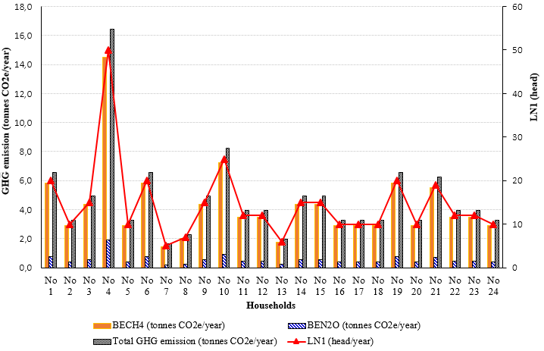  Figure 1 GHG emission due to composting at 24 households
Table 1 GHG emission at Van Cu rice noodle craft village
 | GHG emission due to composting |  | GHG emission due to burning fuel |  | Total GHG emission
 | BE_{CH4} (tonnes CO₂e/year) | BE_{N2O} (tonnes CO₂e/year) | B_{CO2} (tonnes CO₂e/year) | B_{CH4} (tonnes CO₂e/year) | BE_{i} (tonses CO₂e/year)
Total | 745,79 | 97,44 | 6732,01 | 17,87 | 7.593,1
Average | 74,58 | 9,74 | 673,20 | 1,79 | 759,3
3.1.2.2 The estimation of GHG emission after using biogas digesters
According to survey data, households used to mainly fuel from wood and gas to serve cooking, breeding and producing rice noodle before they had biogas digesters. With H= 0,8%; VS= 0,3 kg dry weight/head/day; B_{o}= 0,29 m³/kg VS; D_{CO2}= 1.798 kg/m³, LN₂= 16 heads/year, total GHG emission of households that used to biogas digesters was 267.6 tonnes CO₂e/year, average GHG emission of every household was 11.2 tonnes CO₂e/year; in which the rate of GHG was 6.4% of using biogas, 87.3% of using wood and 6.2% of reaching from biogas digesters. Total GHG reduction was 956.7 tonnes CO₂e/year, average GHG emission was 39.9 tonnes CO₂e/year/household. Thus, the output of CERs sale reached 12,922,034 VND/year, average of houshold saved to 538,418 VND/year/hosehold (see Table 2). Van Cu rice noodle craft village had 264 households to join in swine breeding. If all of households in this village will build biogas digester, total GHG emission may be reduce 10.523,9 tonnes CO₂e/year, coressponding to the outcome of CERs sale will reach 142,142,379 VND/year.
Table 2 GHG reducing by using biogas digesters at 24 households
 | Total GHG emission |  |  | CERs price (EUR/tonnes CO₂e), in 2013 | Outcome
 | BE_{i} (tonnes CO₂e/year) | PE_{i} (tonnes CO₂e/year) | ER_{i} (tonnes CO₂e/year) | CERs price (EUR/tonnes CO₂e), in 2013 | (EUR/  year) | (VND/  year)
Total | 1.224,3 | 267,6 | 956,7 | 0,5 | 516,6 | 12.922.034
Average | 51,0 | 11,1 | 39,9 | 0,5 | 21,5 | 538.418
Notes: 1 EUR = 25.012,31 VND on 26 April, 2017.
3.2. Conclusions
Rice noodle production and swine breeding not only brought economic effectiveness for households but also caused environmental pollution issues (such as wastewater, solid waste, GHG emission etc.) that was concerned at Van Cu village, Thua Thien Hue province. When households at village enhance some solutions to recycling by-products to serve breeding and saving fuel by using biogas digesters that will reduce GHG emission. Total GHG emission was reduced 956.7 tonnes CO₂e/year. Therefore, the outcome of CERs sale reached 12,922,034 VND/year, every household will save 538.418 VND/year/household. Total GHG emission of Van Cu village will reduce 10,523.9 tonnes CO₂e/year, equivalent to CERs sale cost will reach 142,142,379 VND/year.

References
- Dong H., Mangino J., McAllister T.A., Hatfield J.L., Johnson D.E., Lassey K., Lima M.A. and Romanovskaya D. (2006), Intergovernmental Panel on Climate Change (IPCC) Guidelines for National Greenhouse Gas Inventories, Volume 4: Agriculture, forestry and other land use, Chapter 10: Emissions from livestock and manure management. Kanagawa, Japan, 1-87.
- Nguyễn Thanh Sơn, Nguyễn Quang Khải, Lê Thị Xuân Thu (2008), Sổ tay sử dụng khí sinh học. Dự án chương trình khí sinh học cho ngành chăn nuôi Việt Nam 2007-2011, Hà Nội, 1 - 45.
- United Nations Framework Convention on Climate Change (2009), Vietnam National Biogas Programmer (PoA) North- East Zone. Clean Development Mechanism Small-scale Program Activity Design Document Form, 53175 Bonn, Germany.

